Goal Setting Sheet Name:__________________________ Class/Day:_________



*Fitness goals can make working out exciting and challenging as you move toward the vision established within your mind's eye.*

*Reaching the finish line is easy if you set goals!*

Goals for a Successful Workout Plan…

1. **Please establish at least three personal fitness goals**. *A good goal must be a) written, b) challenging, c) believable, d) specific, e) measureable, and f) have a specific deadline.*

A.

B.

C.

1. **I plan to monitor my progress by**:

*Examples: Taking heart rates, using heart rate monitors, measuring pre and post, keeping a log, pedometer, and indicating where I need to increase weight, reps, intensity, and time.*

1. **Motivational strategies to assist me in adhering to my plan will include**:

*Examples: Working with a partner, engaging in a variety of activities, self-affirmations, music, etc…*

### AFFIRMATIONS *(Examples)*

* I feel happy, I feel healthy and I feel great!
* I feel a divine sense of well-being, high self-esteem and confidence.
* I have a high level of self-esteem and energy.
* I believe I am worthy and deserving of great things in life.
* I choose foods that are healthy for me.
* I am optimistic and I feel great in my life.
* I accept the conditions of my life with love and self-appreciation.
* I am connected to the source energy within me which provides me with a divine abundance of health, wealth and happiness.

Include your own affirmation(s):

____________________________________________________________________________

Directions for Designing and Implementing a Fitness Plan

1. Evaluate your fitness.
2. Set attainable goals.
3. Choose and develop an *exercise/workout plan*.
4. Pick activities in which you enjoy, have some skill or ability in, or because you’re just interested in learning/experiencing something new.
5. Select the most convenient time and follow a regular schedule so that exercise becomes a part of your day (a habit.)
6. Structure your program by making a weekly plan and keep a journal of your activities.
7. ***Illustrate knowledge of all Training Principles throughout your plan.*** 
   * 1. F.I.T.T. Principle
     2. Overload Principle
     3. Principle of Specificity
     4. THRZ (Exercise within your Target Heart Rate Zone)
8. ***Incorporate the Health-Related Components of Fitness*** to your plan. (*Cardiovascular endurance, muscular strength and endurance, flexibility and body composition.)*
9. Gradually and progressively increase frequency, intensity, time and type.
10. Each exercise session should include a warm-up, main workout, and cool down period.
11. Try different activities and schedules until you find the one that’s right for you.
12. Look for gradual changes over the next few weeks and months ahead.
13. Show VARIETY in your workouts!
14. Utilize resources available… (Magazine workouts, DVD workouts, PE classes, sport workouts, group fitness workouts, fitness/health clubs, YMCA, yoga studio, etc…)
15. Make fitness a lifetime commitment.
16. The best time to start your fitness habit is NOW! If you begin exercising regularly while you’re young, then it’s likely you will continue exercising for a lifetime.

[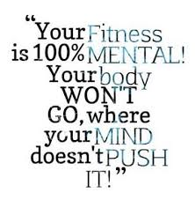](http://www.google.com/url?sa=i&rct=j&q=&esrc=s&frm=1&source=images&cd=&cad=rja&uact=8&docid=4UaiBlo9XNFErM&tbnid=f_0GrAW9DMtxJM:&ved=0CAcQjRw&url=http://www.motivationblog.org/fitness-quote/&ei=LEMTVK-4N4mMjAK6_IGgBw&bvm=bv.75097201,d.aWw&psig=AFQjCNEjoYeCcDUXDszrOzLUALZcvwZzgw&ust=1410634080311898)

[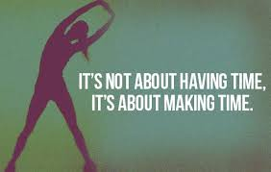](http://www.google.com/imgres?imgurl=http://eatdrinkpaleo.com.au/wp-content/uploads/2012/06/Motivational_fitness_quotes_3.jpg&imgrefurl=http://eatdrinkpaleo.com.au/10-motivating-fitness-quotes-to-get-you-going/&h=350&w=550&tbnid=qFdCSdDawYP6RM:&zoom=1&docid=a8B3gmPVBmd48M&ei=6j8TVOOEEsOTyASij4CwDQ&tbm=isch&ved=0CEAQMyg4MDg4ZA&iact=rc&uact=3&dur=6915&page=5&start=138&ndsp=36)[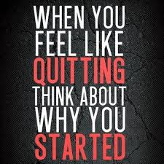](http://www.google.com/url?sa=i&rct=j&q=&esrc=s&frm=1&source=images&cd=&cad=rja&uact=8&docid=4NpU1E2B2Gwg4M&tbnid=IJ7amWDGAheZ1M:&ved=0CAcQjRw&url=http://www.juxtapost.com/site/permlink/e4543ca0-4aba-11e3-a66b-2ba6aad07477/post/think_about_why_you_started_quotes_quote_fitness_workout_motivation_exercise_motivate_workout_motivation_exercise_motivation_fitness_quote_fitness_quo/&ei=-UATVO7kA8K6igK19YGAAw&bvm=bv.75097201,d.aWw&psig=AFQjCNEjoYeCcDUXDszrOzLUALZcvwZzgw&ust=1410634080311898)